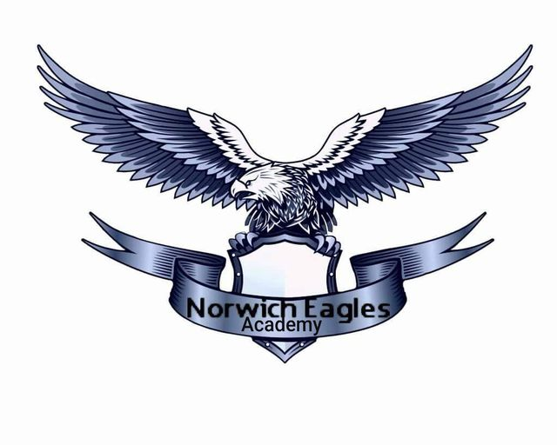 | Norwich Eagles Academy  Open Academy  Sallhouse Road  Norwich , NR7 9DL
CLUB REGISTRATION & PLAYER INFORMATION

First Name of Child
Surname of Child
Date of Birth
Gender
Address

Postcode
Telephone Number - Home
Telephone Number - Mobile
Email
Year Group of School
Previous Club
Surgery Name
Address

Telephone Number
Please list any medical conditions or medication that your child is taking

Please list any allergies your child may have

1st Emergency Contact Name
Number
2nd Emergency Contact Name
Number
Father`Full Name
Address
(if different from child)
Telephone Number
Mother`s Full Name
Address
(if different from child)
Telephone Number
Are any of the parent guardian?
If no,name the guardian
Telephone Number

